MINISTRY OF EDUCATION AND TRAINING
UNIVERSITY OF ECONOMICS AND FINANCE
HO CHI MINH CITY
---------------------------


FINAL PROJECT REPORT
SOFTWARE QUALITY VERIFICATION
TOPIC: ONLINE SALES MANAGEMENT SYSTEM

Class: 252.ITE1231E.A02E
Instructor: MSc. Nguyễn Ngọc Tú

Performed by Student:
Hoàng Văn Thiên | 22D1ITE-SWE03 | 225051915
Nguyễn Thành Đạt | 22D1ITE-SWE03 | 225050896
Lê Quang Duy | 22D1ITE-SWE03 | 225051169

Ho Chi Minh City, April 2026

RECORD OF CHANGES
This section summarizes the major revision milestones of the final report and the submission package. Only meaningful changes that affected scope, execution, evidence, defects, metrics, or final packaging are recorded here.
Table R.1: Record of changes
Version | Date | Author | Change Summary
0.1 | 2026-04-05 | QA Team | Established the report structure, completed the initial project audit, and defined the first testing scope and plan baseline.
0.5 | 2026-04-05 | QA Team | Added the UI and API test cases, prepared the test data set, and documented the initial automation approach.
0.8 | 2026-04-06 | QA Team | Added execution evidence, initial defect records, early metrics, and supporting automation outputs.
1.0 | 2026-04-06 | Hoang Van Thien | Consolidated the main report content, appendix linkage, and final submission package structure.
1.1 | 2026-04-10 | QA Team | Expanded verified UI execution coverage and synchronized the report with the updated results, metrics, and evidence set.
1.2 | 2026-04-11 | QA Team | Removed the remaining Not Run status, synchronized the live GitHub Issues, and refreshed the defect and metrics sections.
1.3 | 2026-04-12 | QA Team | Finalized chapter wording, references, appendix content, formatting consistency, and submission-ready packaging.

LIST OF CONTENTS
RECORD OF CHANGES 2
LIST OF CONTENTS i
LIST OF FIGURES iii
LIST OF TABLES iv
CHAPTER 1. OVERVIEW 1
1.1. Project Information 1
1.1.1. System overview 1
1.1.2. Main business modules 3
1.1.3. API overview 4
1.2. Project Team and Task Allocation 6
1.2.1. Team members 6
1.2.2. Responsibility matrix 7
CHAPTER 2. TEST PLAN 9
2.1. Test Scope 9
2.1.1. In-Scope 9
2.1.2. Out-of-Scope 10
2.2. Test Strategy & Approach 11
2.2.1. Manual testing approach 11
2.2.2. Basic automation approach 12
2.2.3. Black-box testing 13
2.2.4. White-box testing 14
2.2.5. Entry and exit criteria 15
2.3. Test Environment 16
2.3.1. Hardware and software environment 16
2.3.2. Browsers, OS, devices 17
2.3.3. Test accounts and test data 18
2.3.4. Tools used 19
CHAPTER 3. TEST DESIGN & EXECUTION 21
3.1. Test Scenarios 21
3.1.1. UI test scenarios 21
3.1.2. API test scenarios 22
3.1.3. Edge cases and exception scenarios 23
3.2. Test Case Specification 25
3.2.1. UI test cases 25
3.2.2. API test cases 28
3.2.3. Test case allocation by member 29
3.2.4. Execution evidence summary 30
CHAPTER 4. DEFECT REPORT & METRICS 32
4.1. Bug Management Tool and Workflow 32
4.1.1. Selected tool 32
4.1.2. Issue workflow 33
4.1.3. Severity and priority rules 34
4.2. Defect Log 35
4.2.1. Critical and high severity defects 35
4.2.2. Medium and low severity defects 37
4.2.3. Screenshots and reproduction evidence 38
4.3. Test Summary Metrics 40
4.3.1. Total test cases executed 40
4.3.2. Pass/Fail/Blocked statistics 41
4.3.3. Defect count by severity 41
4.3.4. Defect ratio and observations 41
CHAPTER 5. CONCLUSION AND FUTURE WORK 43
5.1. Achievements and compliance with requirements 43
5.2. Challenges and limitations 44
5.3. Suggestions for future enhancements 46
APPENDIX 49
REFERENCES 53
TASK DIVISION AND CONTRIBUTION SUMMARY 54

LIST OF FIGURES
Figure ‎1.1-1: Representative administrative interface evidence after successful login to the system. 2
Figure ‎1.1-2: Representative administrative modules and management screens included in the test scope. 4
Figure ‎1.1-3: Newman execution evidence for the API test suite. 5
Figure ‎2.2-1: Representative API automation execution output using Newman. 13
Figure ‎2.3-1: Representative secured administrative environment and module access used during UI testing. 18
Figure ‎2.3-2: Representative controlled validation dataset behavior during product import testing. 19
Figure ‎3.1-1: Example UI execution evidence for a successful authentication scenario. 22
Figure ‎3.1-2: API scenario execution evidence produced by the Newman full-run output. 23
Figure ‎3.1-3: Example edge-case evidence from the product import preview validation flow. 25
Figure ‎3.2-1: Defect-focused UI execution evidence for invoice creation failure. 28
Figure ‎4.1-1: GitHub Issue example used as the official bug-management record for a confirmed defect. 33
Figure ‎4.2-1: Reproduction evidence for the high-severity invoice creation defect. 36
Figure ‎4.2-2: GitHub Issue evidence for a high-severity invoice cancellation defect. 37
Figure ‎4.2-3: GitHub Issue evidence for the medium-severity purchase validation defect. 38
Figure ‎4.2-4: GitHub Issue evidence for the product-import confirmed defect. 40
Figure ‎4.3-1: Metrics summary exported from the synchronized results workbook 42
Figure ‎5.1-1: Final execution and metrics summary used to support the conclusion of the testing project. 44
Figure ‎5.2-1: Example of a confirmed open defect that remains unresolved at the final reporting point. 46
Figure ‎5.3-1: Existing automation evidence that can be expanded in future iterations to increase regression strength. 47

LIST OF TABLES
Table ‎1.1-1: System overview 2
Table ‎1.1-2: Main business modules 3
Table ‎1.1-3: API overview 5
Table ‎1.2-1: Team members 7
Table ‎1.2-2: Responsibility matrix 8
Table ‎2.1-1: In-scope test areas 10
Table ‎2.1-2: Out-of-scope items 11
Table ‎2.2-1: Automation strategy overview 12
Table ‎2.2-2: Black-box and white-box usage 14
Table ‎2.2-3: Entry and exit criteria 15
Table ‎2.3-1: Hardware and software environment 16
Table ‎2.3-2: Browsers, OS, and devices 17
Table ‎2.3-3: Test accounts and test data 18
Table ‎2.3-4: Tools used 20
Table ‎3.1-1: UI scenario distribution by interface 21
Table ‎3.1-2: Representative UI scenario groups 22
Table ‎3.1-3: API scenario coverage 23
Table ‎3.1-4: Representative edge and exception scenarios 24
Table ‎3.2-1: Sample UI test case specification (positive case) 25
Table ‎3.2-2: Sample UI test case specification (defect-focused case) 26
Table ‎3.2-3: Sample API test case specification 28
Table ‎3.2-4: Test case allocation by member 29
Table ‎3.2-5: Execution evidence summary 30
Table ‎3.2-6: Execution evidence types 30
Table ‎4.1-1: Bug-management tool selection 32
Table ‎4.1-2: Issue workflow 34
Table ‎4.1-3: Severity and priority rules 34
Table ‎4.2-1: High-severity confirmed defects 35
Table ‎4.2-2: Medium and low severity confirmed defects 37
Table ‎4.2-3: Defect evidence mapping summary 39
Table ‎4.3-1: Execution totals 40
Table ‎4.3-2: Pass / Fail / Blocked statistics 41
Table ‎4.3-3: Confirmed defect count by severity 41
Table ‎4.3-4: Defect ratio and observations 42
Table ‎5.1-1: Final requirement compliance summary 43
Table ‎5.1-2: Final delivery baseline 44
Table ‎5.2-1: Current limitations and impact 45
Table ‎5.3-1: Recommended future enhancement roadmap 47
Table ‎A.1: GitHub submission links 49
Table ‎A.2: Excel and scenario artifacts 49
Table ‎A.3: Test scripts and test data 50
Table ‎A.4: Final results and evidence package 51
Table ‎A.5: Automation video artifacts 52
Table ‎A.6: Bug tracker and defect artifacts 52
Table ‎T.1: Task division and contribution summary 54

OVERVIEW

Project Information
This report presents the software-testing study and final submission for the Online Sales Management System, a web-based business application developed on ASP.NET Core MVC (.NET 8). The system is designed to support core sales and inventory operations, including user authentication, product management, supplier management, customer management, purchase handling, invoice processing, stock monitoring, reporting, and public product browsing.
The main purpose of this project is to evaluate whether the system behaves correctly in its business-critical workflows and whether the final submission satisfies the course requirements for test planning, test-case design, execution evidence, bug management, reporting quality, and basic automation. The testing effort was conducted using a combination of manual testing, API testing, and targeted automation. All major claims in this report are supported by execution artifacts such as screenshots, Excel workbooks, automation outputs, runner files, GitHub Issues, and a recorded automation video.
This project is well suited for a software-testing study because it combines several functional surfaces with business rules that can fail in meaningful ways. Purchase and invoice workflows affect inventory and transaction states, role-based access control determines which functions each user can reach, and product import adds validation and batch-processing risk. These characteristics made the system suitable for structured test design, real execution, defect reporting, and evidence-based analysis.

System overview
The Online Sales Management System is an internal-and-public web application that supports both operational users and public visitors. The internal area provides a secured administrative interface where authorized users can manage products, suppliers, customers, purchases, invoices, stock records, and business reports. The public area provides product discovery features for browsing, filtering, sorting, and viewing product details.
The system follows a layered ASP.NET Core MVC architecture and uses a relational database for persistent storage. Authentication and authorization are handled through ASP.NET Identity, while Entity Framework Core supports the data-access layer. In addition to the browser-based interface, the project exposes a small API surface for health checking and public catalog retrieval. This gave the team a practical test scope: broad enough to include both UI and API verification, but still manageable within the project timeline.
For the purpose of the final submission, the system was tested as a locally executed environment using seeded demo data. This allowed the team to verify realistic workflows such as valid login, invalid login, role restrictions, product creation, purchase draft creation, invoice processing, stock-related views, reporting filters, product import validation, and catalog API behavior. The system therefore represents a practical case study for end-to-end software testing rather than a purely theoretical exercise.
Table ‎1.1-1: System overview
Item | System description
System name | Online Sales Management System
System type | Web-based sales and inventory management system
Architecture style | ASP.NET Core MVC application with database-backed business workflows
Primary users | Administrative users and public catalog visitors
Main interfaces | Admin UI, Public UI, Health API, Catalog API
Testing objective | Verify business-critical workflows, validation behavior, permissions, and API responses

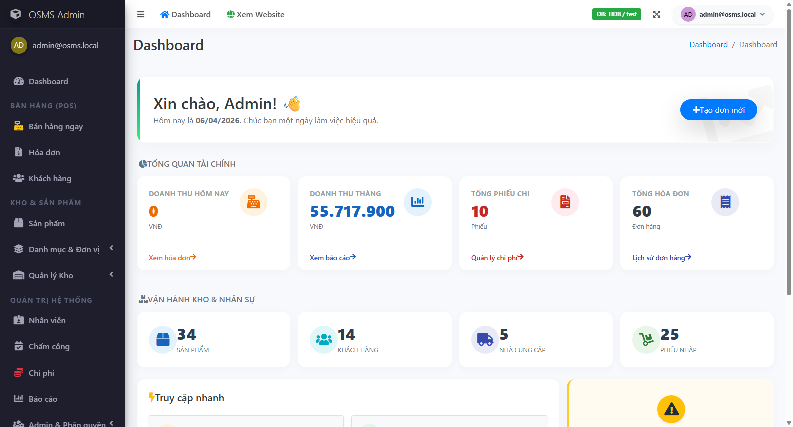
Figure ‎1.1-1: Representative administrative interface evidence after successful login to the system.

Main business modules
The system contains several business modules that are directly related to daily operational activities. These modules were selected as the primary testing targets because incorrect behavior in any of them could affect business continuity, inventory accuracy, transaction correctness, or access control.
The Authentication and Permissions modules control whether a user can log in successfully and whether the user can access only the functions allowed by his or her assigned role. These modules are foundational because every secured business workflow depends on them. The Products, Suppliers, and Customers modules provide core master-data management and therefore affect downstream processes such as purchases and invoices.
The Purchases and Invoices modules are the most business-critical workflows in the system. Purchase processing affects inbound stock and supplier-side records, while invoice processing affects outbound stock, payment states, and customer transactions. The Product Import module introduces additional risk because it handles multi-row validation and batch-style updates. The Stock and Reports modules are also high value because they influence operational decisions and managerial visibility. Finally, the Public Catalog module, although smaller in scope, is important because it represents the customer-facing browsing surface of the system.

Table ‎1.1-2: Main business modules
Module | Business purpose | Testing importance
Authentication | Allows valid users to access the system securely | High
Permissions / Authorization | Restricts access based on user role | High
Products | Manages product master data and sales items | High
Suppliers | Manages supplier information used by purchases | Medium
Customers | Manages customer records used by invoices | Medium
Purchases | Handles inbound stock and purchasing workflows | High
Invoices | Handles sales transactions, payment, and stock deduction | High
Product Import | Supports bulk product validation and import processing | High
Stock | Shows inventory state and stock movement information | High
Reports | Provides summary and filtered business reports | Medium
Public Catalog | Supports public browsing, filtering, and product details | Medium

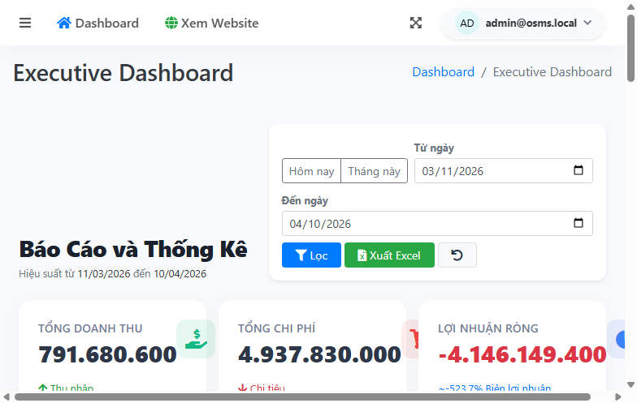
Figure ‎1.1-2: Representative administrative modules and management screens included in the test scope.

API overview
Although the project is primarily UI-driven, it also exposes a limited but meaningful API surface that supports monitoring and public catalog retrieval. This API layer was included in the final submission because it provides stable request-response targets that are suitable for systematic verification with Postman and Newman.
The Health API is used to confirm service availability and payload consistency. It allows the testing team to verify whether the application is running correctly and whether the returned metadata remains structurally valid. The Catalog API provides public-facing product retrieval functions, including product listing, product-detail retrieval, trending data, and filter information. These endpoints were valuable for validating status codes, response payloads, query handling, and negative scenarios such as invalid parameters or unsupported sort values.
Testing the API surface strengthens the report in two ways. First, it complements the UI coverage by validating backend-accessible behavior directly. Second, it provides repeatable execution outputs through Newman, including text summaries and XML runner artifacts. This makes the API section easier to verify and easier to defend during review.
Table ‎1.1-3: API overview
API area | Purpose | Representative endpoints
Health API | Service status verification | GET /api/v1/health
Catalog product list | Public catalog retrieval | GET /api/v1/catalog/products
Catalog product detail | Single product information retrieval | GET /api/v1/catalog/products/{id}
Trending products | Returns popular or highlighted items | GET /api/v1/catalog/trending
Catalog filters | Provides available filtering metadata | GET /api/v1/catalog/filters

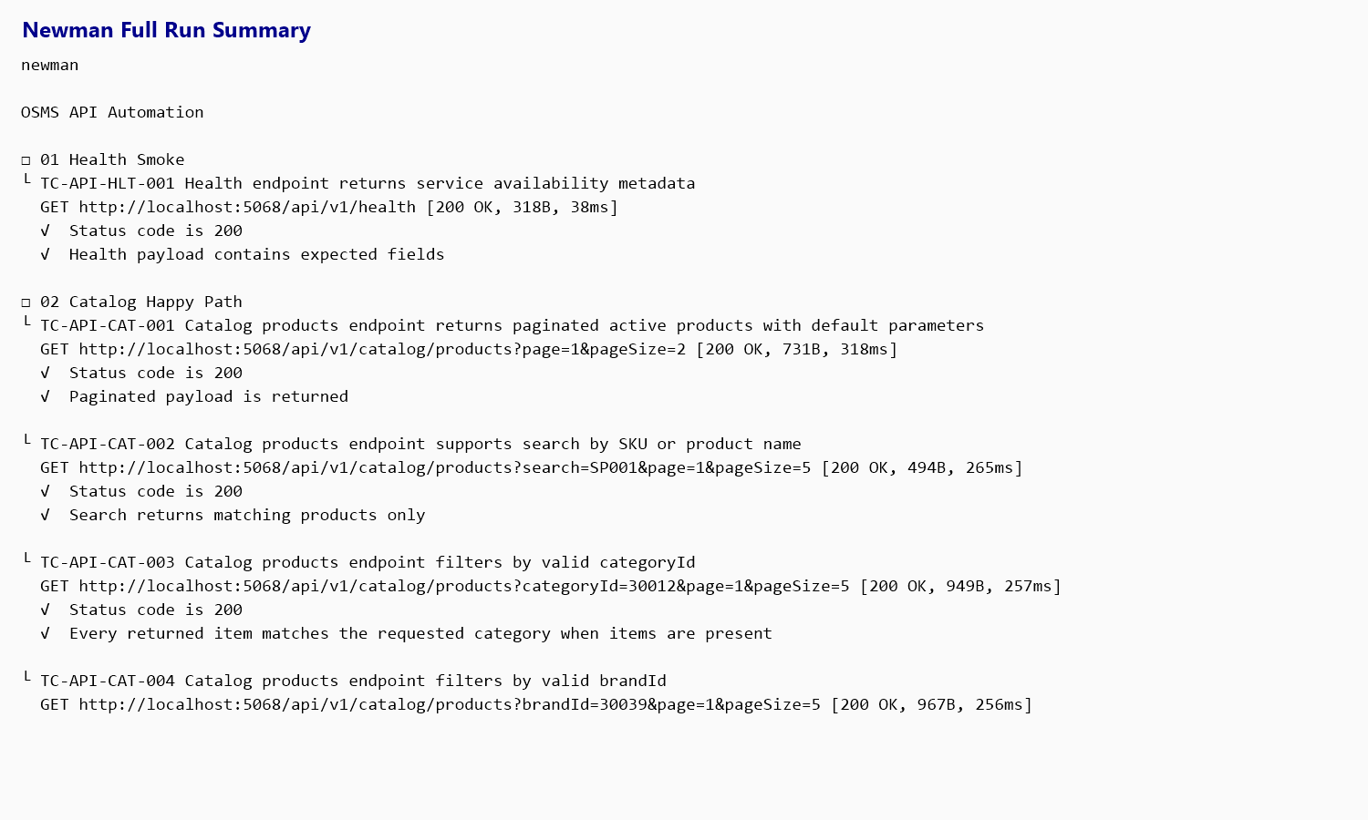
Figure ‎1.1-3: Newman execution evidence for the API test suite.

Project Team and Task Allocation
The testing project was completed by a three-member QA team. Task allocation was planned carefully to satisfy the course requirement that each member contribute at least ten non-overlapping test cases. Instead of distributing work randomly, the team assigned module ownership so that each member could focus on a specific functional area while still contributing to the integrated final submission.
This structure made ownership clearer and helped the team keep the final artifacts consistent. Each member was responsible for designing, executing, and documenting test cases within defined module boundaries. Shared artifacts such as the final report, metrics workbook, defect register, and automation evidence were synchronized only after the execution baseline had been verified. This reduced overlap and made it easier to connect each result, screenshot, and defect record back to a clear owner.
In addition to module ownership, one member also coordinated final integration and submission consistency checks. This role was necessary because the final package includes multiple artifact types and requires strong cross-file traceability between scenarios, test cases, results, metrics, defect records, automation outputs, and presentation materials.

Team members
The project team consists of three members from the same class group. Each member was assigned a distinct module cluster and was required to contribute a sufficient number of individual test cases. The final workload distribution satisfies the requirement that every member owns more than ten UI test cases.
Hoang Van Thien handled the largest share of UI ownership and also led the project audit, artifact alignment, and final report consolidation. Nguyen Thanh Dat focused mainly on customer, supplier, purchase, and part of the stock workflows. Le Quang Duy focused mainly on product, product import, stock-related, and public-catalog workflows. This division kept responsibilities clear while helping the team maintain a consistent final package.

Table ‎1.2-1: Team members
Member | Class | Student ID | Main ownership | UI cases owned
Hoang Van Thien | 22D1ITE-SWE03 | 225051915 | Authentication, Permissions, Admin Users, Admin Groups, Invoices, Reports, partial Public Catalog | 17
Nguyen Thanh Dat | 22D1ITE-SWE03 | 225050896 | Customers, Suppliers, Purchases, partial Stock | 13
Le Quang Duy | 22D1ITE-SWE03 | 225051169 | Products, Product Import, partial Stock, Public Catalog | 14

Responsibility matrix
To ensure non-overlapping ownership and a clear final submission structure, the team used a module-based responsibility matrix. Each member was primarily responsible for the test design and execution of a specific functional area, while final integration activities were coordinated centrally to keep the report, metrics, defects, and supporting evidence consistent.
This matrix also reflects the practical reality of the project. Some deliverables, such as the final report, metrics workbook, defect synchronization, and automation packaging, required cross-member review. However, the ownership model remained clear enough that each module can be traced back to a primary contributor. This is important not only for grading compliance but also for presentation defense, where each member must be able to explain the rationale, execution, and evidence behind the parts they owned.

Table ‎1.2-2: Responsibility matrix
Work item | Primary owner | Supporting members
Project audit and scope definition | Hoang Van Thien | Nguyen Thanh Dat, Le Quang Duy
Authentication and permission testing | Hoang Van Thien | -
Admin users and admin groups testing | Hoang Van Thien | -
Invoice and report testing | Hoang Van Thien | -
Customer and supplier testing | Nguyen Thanh Dat | -
Purchase workflow testing | Nguyen Thanh Dat | -
Stock-related testing | Nguyen Thanh Dat / Le Quang Duy | Shared coverage by module split
Product testing | Le Quang Duy | -
Product import testing | Le Quang Duy | -
Public catalog testing | Le Quang Duy / Hoang Van Thien | Shared coverage by scenario split
API testing and Newman execution | QA team | Shared execution and verification
Automation framework maintenance | QA team | Coordinated integration
Final results, metrics, and defect synchronization | Hoang Van Thien | QA team
Final report and presentation consolidation | Hoang Van Thien | QA team

Overall, the team allocation satisfies the course requirements for minimum contribution, non-overlapping test ownership, and traceable responsibility. This structure also supports stronger evidence management because each module, test case set, execution artifact, and defect record can be linked back to a clearly assigned owner and a verifiable workflow.

TEST PLAN

Test Scope
This chapter defines the boundaries of the testing effort for the Online Sales Management System. The scope was determined based on business impact, functional importance, visible user workflows, and source-informed risk analysis. Priority was given to areas where failures could directly affect access control, transaction correctness, inventory consistency, bulk data handling, and managerial visibility.
The final scope includes both user-facing and backend-accessible components. UI testing was prioritized for the administrative interface and the public product catalog, while API testing was used for the exposed health and catalog endpoints. This combination helped the team cover both visible business behavior and direct request-response validation without expanding the project beyond a manageable level.

In-Scope
- The following items were included in the official testing scope of this submission:
- Authentication and login validation
- Role-based access control and permission boundaries
- Admin user and admin group management
- Customer and supplier master-data workflows
- Product creation, update validation, duplicate checking, and product-state management
- Product import validation, preview behavior, and import confirmation flow
- Purchase creation, receiving, cancellation, and related validation behavior
- Invoice creation, payment, cancellation, and inventory-related business behavior
- Stock visibility, low-stock views, and stock-movement filtering
- Report filtering and export-related source verification
- Public product catalog search, filtering, sorting, and detail pages
- API verification for health and public catalog endpoints
- Execution evidence collection, defect logging, metrics generation, and traceability mapping
Table ‎2.1-1: In-scope test areas
Scope item | Description
Admin UI | Authentication, permissions, master data, purchases, invoices, stock, reports
Public UI | Product search, filtering, sorting, and detail pages
API surface | Health endpoint and public catalog endpoints
Business validation | Input validation, duplicate handling, role restrictions, inventory-sensitive rules
Defect workflow | Execution evidence, GitHub Issues, defect log, metrics, and result traceability
Automation support | UI and API automation for selected high-value flows

Out-of-Scope
The following items were excluded from the scope of this submission due to time, environment, or project-boundary limitations:
- Performance and load testing
- Penetration testing and deep security assessment
- Mobile application testing
- Full responsive certification across multiple mobile and tablet devices
- Accessibility compliance audit
- Disaster recovery, backup, and failover testing
- Browser compatibility beyond the verified baseline and basic smoke validation
- Undocumented write apis outside the exposed catalog and health endpoints
- Production deployment validation and cloud-infrastructure testing
These exclusions do not reduce the validity of the current testing scope. Instead, they clarify that the submission is focused on functional correctness, execution evidence, and business-rule verification rather than non-functional certification.
Table ‎2.1-2: Out-of-scope items
Excluded item | Reason for exclusion
Performance / load testing | Not required by the course scope and no dedicated load environment was provided
Deep security testing | Requires specialized tools and a different testing objective
Mobile / device matrix | Not part of the required deliverables for this final submission
Full cross-browser certification | Only basic browser verification was feasible within the available environment
Infrastructure / deployment testing | Project was executed in a local testing environment, not a production-like deployment target

Test Strategy & Approach
The testing strategy was designed to keep coverage broad while still producing evidence that the team could explain and defend. Because the system includes both interactive business workflows and a small API surface, the team combined manual testing, API testing, and selective automation. This allowed the report to cover visible user behavior, backend-accessible responses, and repeatable high-value flows without overstating the maturity of the automation layer.
The strategy was primarily risk-based. Business-critical workflows such as authentication, permission boundaries, purchases, invoices, stock-sensitive operations, and product import were prioritized because defects in these areas could lead to data inconsistency, incorrect transaction behavior, or operational failures. Lower-risk areas such as cosmetic formatting and deep non-functional properties were not prioritized in the same way.

Manual testing approach
Manual testing was the primary execution method for the submission because it provides the broadest coverage for visible business behavior, validation feedback, access-control behavior, workflow branching, and exception handling. It was especially important for modules where human observation is necessary to verify form behavior, redirects, inline validation, data persistence, and functional correctness across multiple screens.
The manual approach followed a structured sequence:
- Prepare the environment and seeded test data
- Identify the target test case and required preconditions
- Execute the defined steps exactly as documented
- Compare actual system behavior against the expected result
- Capture screenshots or output artifacts
- Record the final result in the workbook
- Log a defect when the mismatch is reproducible and supported by evidence

Basic automation approach
Basic automation was implemented to strengthen repeatability and bonus coverage rather than to replace the full manual test effort. Two automation layers were used in this project.
First, UI automation was implemented using Selenium WebDriver with .NET 8 and xUnit. This layer was used for selected high-value workflows such as login verification, permission checks, purchase creation, invoice-related validation, import preview behavior, and focused reruns for regression confirmation.
Second, API automation was implemented using Postman collections executed through Newman. This layer was used to verify health and catalog endpoints in a repeatable way and to produce exportable evidence such as text summaries and XML result files.
The automation scope was kept selective so that the automated outputs remained stable, reviewable, and clearly linked to the official test cases. The goal was not to claim full regression automation, but to provide credible support for repeated UI and API verification with real artifacts such as screenshots, TRX files, Newman text output, and XML runner results.
Table ‎2.2-1: Automation strategy overview
Automation type | Technology | Main purpose
UI automation | Selenium WebDriver + .NET 8 + xUnit | Repeatable verification of selected high-value UI workflows
API automation | Postman + Newman | Repeatable verification of exposed API endpoints and exportable runner evidence
Evidence output | Screenshots, TRX, TXT, XML | Support result comparison, execution traceability, and bonus coverage


Figure ‎2.2-1: Representative API automation execution output using Newman.

Black-box testing
Black-box testing was the dominant testing strategy used in this project. Test execution focused on system inputs, user actions, visible outputs, and business outcomes without depending on internal implementation details during runtime verification.
This strategy was applied to:
- Login success and login rejection
- Role-based access restriction
- Crud validation for products, suppliers, and customers
- Purchase and invoice workflow outcomes
- Product import validation and confirmation behavior
- Public catalog search, sorting, and filtering behavior
- Api status codes and payload validation
Black-box testing was the most suitable execution approach for this project because the course emphasizes practical test design, visible system behavior, and real execution evidence. It also matched the way the team verified business workflows through forms, redirects, validation messages, permissions, and API responses.

White-box testing
White-box testing was not used as a standalone implementation-heavy testing stream such as unit-test-driven structural coverage. However, white-box-informed analysis was used to support test design. The team inspected the source code, routes, controllers, validation logic, and seeded data in order to identify hidden edge cases, role conditions, unsupported inputs, and risky business-rule paths before executing the test cases.
This code-informed analysis helped the team design stronger scenarios for:
- Permission boundaries across admin, sales, and warehouse roles
- Invoice creation and cancellation behavior
- Import validation rules and preview-confirm flow
- Unsupported api query values
- Route access and redirection logic
- Stock-sensitive workflows and business-state transitions
Overall, the project used a black-box execution model supported by source-informed test design. This was a practical way to combine real user-facing execution with code inspection, especially for permission rules, validation paths, and business-state transitions that are not always obvious from the interface alone.
Table ‎2.2-2: Black-box and white-box usage
Approach | How it was used in this project
Black-box | Main execution strategy for UI and API verification based on inputs, actions, and visible outputs
White-box-informed | Used during test design through source inspection to identify edge cases, hidden branches, and risky logic
Reason for combination | Improves design quality without overstating the presence of deep structural automation or unit-level coverage

Entry and exit criteria
Entry and exit criteria were defined to keep execution disciplined and to ensure that reported results were supported by reproducible evidence.
Entry criteria for execution:
- The application builds and runs successfully in the local environment
- The target base url is reachable
- Seeded accounts and required test data are available
- The required test case, preconditions, and test data are prepared
- The evidence folders and result workbooks are ready for recording outputs
- The target module can be opened in the environment being used
Exit criteria for the testing cycle:
- All designed UI and API test cases in the documented scope have been executed.
- Actual results and final statuses have been recorded
- Screenshots, runner outputs, and evidence files have been stored
- Confirmed mismatches have been logged into the defect register and github Issues
- Final results, metrics, and traceability files have been synchronized
- The report and presentation reflect the latest execution baseline
The execution cycle satisfied the defined exit criteria for coverage and documentation. However, product-quality closure was not fully achieved because four confirmed defects remained open at the final reporting point.
Table ‎2.2-3: Entry and exit criteria
Criteria type | Definition
Entry criteria | Application is runnable, test data is available, target module is reachable, and evidence recording is ready
Exit criteria | All test cases are executed, results are recorded, defects are logged, and artifacts are synchronized
Current status | Execution exit criteria satisfied; product quality still limited by unresolved confirmed defects

Test Environment
A controlled local test environment was used for all verified execution in this submission. The environment was configured to support both manual and automated testing, with the same application instance serving as the source for UI and API verification. Using a single consistent environment reduced result inconsistency and strengthened traceability across screenshots, runner outputs, workbooks, and defect records.
The environment section is important because it defines the reproducibility conditions of the submission. All reported outcomes in the final workbooks and screenshots were produced from this testing baseline unless explicitly stated otherwise.

Hardware and software environment
The execution environment used for the project was a Windows-based local workstation capable of running the ASP.NET Core MVC application, browser-based UI testing, Newman API execution, and supporting evidence tools. The application was executed locally using the .NET 8 runtime and connected to the database environment identified in the system as TiDB / test.
This environment was sufficient for the scope of the final submission because it supported functional execution, screenshot capture, UI automation, API execution, and evidence export. No distributed infrastructure or staging server was required for the tested endpoints and business flows included in the report.
Table ‎2.3-1: Hardware and software environment
Environment item | Value
Operating system | Windows 11
Application framework | ASP.NET Core MVC (.NET 8)
ORM / data access | EF Core
Authentication framework | ASP.NET Identity
Database tag observed in execution | TiDB / test
Execution type | Local environment
Base URL | http://localhost:5068
Repository path | E:\Project\Online-Sales-Management-System

Browsers, OS, devices
The primary browser used for UI execution was Google Chrome. Chrome was used for the main body of manual execution and for the majority of Selenium-based automated runs. In addition, a basic smoke rerun was executed on Microsoft Edge to provide minimal cross-browser evidence for the final submission.
Because the project is a web system and the course does not require a full device-compatibility matrix, testing was performed under desktop conditions only. No mobile-device certification or tablet matrix was included. This browser setup was sufficient for the final submission because Chrome covered the main execution baseline and Microsoft Edge provided a basic compatibility check through a smoke rerun.
Table ‎2.3-2: Browsers, OS, and devices
Item | Usage in testing
Windows 11 | Main execution operating system
Google Chrome | Primary browser for manual UI and Selenium-based execution
Microsoft Edge | Basic smoke verification for limited cross-browser evidence
Desktop / laptop environment | Primary device class used for the final submission
Mobile devices | Not included in the official scope
Tablet devices | Not included in the official scope


Figure ‎2.3-1: Representative secured administrative environment and module access used during UI testing.

Test accounts and test data
The submission relied on seeded demo accounts and controlled test data rather than live production accounts. This approach reduced risk and made execution reproducible. The seeded accounts supported role-based verification across administrative, sales, and warehouse perspectives.
The test data set also included prepared values for product creation, purchase and invoice scenarios, API query combinations, and product import validation files. These datasets allowed the team to verify both happy-path and negative-path behavior in a controlled way.
Sensitive real-world credentials were not stored in the report. Only test-safe and seeded execution data was used for the final submission.
Table ‎2.3-3: Test accounts and test data
Data category | Example / source | Purpose
Admin account | admin@osms.local | Authentication, admin access, invoice, report, and configuration-related workflows
Sales account | sales@osms.local | Permission verification and sales-side behavior
Warehouse account | warehouse@osms.local | Purchase and stock-related verification
Negative login data | Invalid password, unknown email, inactive-account scenarios | Authentication validation
Import dataset | Mixed-validation workbook and invalid-format sample | Product import preview and confirmation testing
API query data | Real category IDs, brand IDs, product IDs, and invalid parameters | Catalog and health API verification
Seeded business data | Products, suppliers, customers, purchases, invoices, stock movement | Business-flow execution support

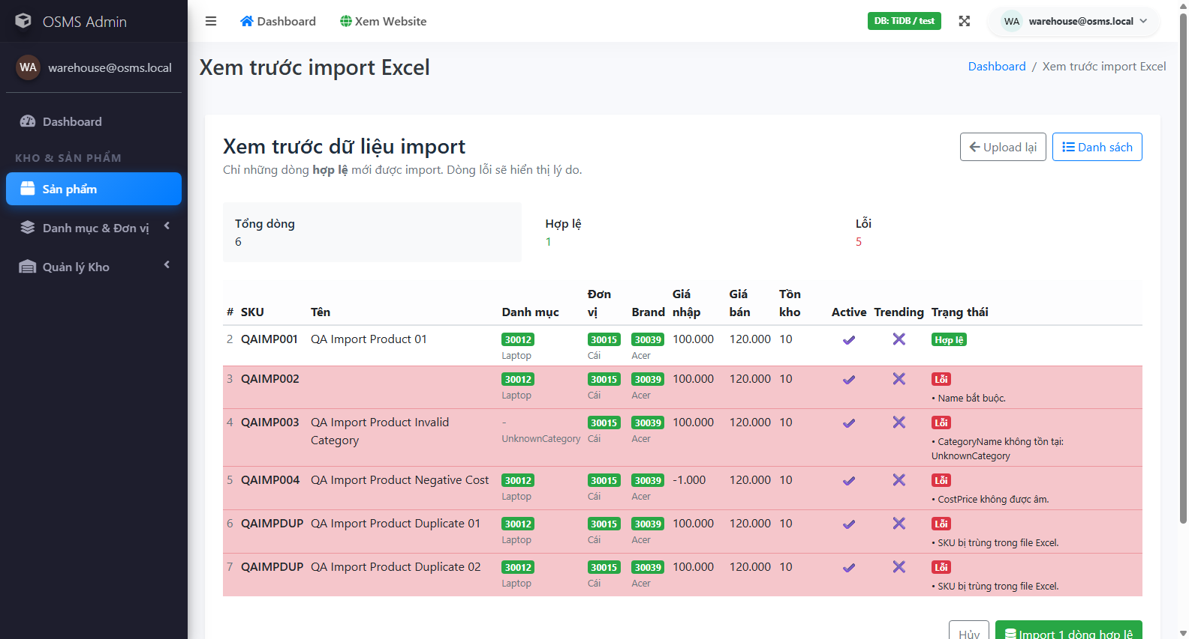
Figure ‎2.3-2: Representative controlled validation dataset behavior during product import testing.

Tools used
The project used a practical set of tools chosen to match the requirements of the course and the structure of the system under test. No unnecessary tooling was introduced. Each tool supported a specific stage of the workflow, including planning, execution, automation, evidence collection, defect logging, and final reporting.
Excel-compatible files were used for traceable test case, result, and metrics management. Selenium WebDriver with xUnit was used for basic UI automation. Postman and Newman were used for API execution and exportable runner outputs. GitHub Issues was used as the real bug-management tool required by the course. Screenshots, TRX files, XML outputs, TXT logs, and the recorded automation video were used to support evidence completeness.
Table ‎2.3-4: Tools used
Tool / technology | Purpose
Microsoft Word | Final report authoring and formatting
Microsoft PowerPoint | Final presentation preparation
Excel-compatible XLSX / CSV | Test cases, final results, metrics, and traceability
Google Chrome | Primary browser for UI execution
Microsoft Edge | Basic cross-browser smoke evidence
Selenium WebDriver + .NET 8 + xUnit | Basic UI automation
Postman | API request design and execution support
Newman | Automated API collection execution and exportable outputs
GitHub Issues | Defect tracking with severity, priority, and labels
Screenshots / TRX / TXT / XML / MP4 | Execution evidence and automation proof

TEST DESIGN & EXECUTION

Test Scenarios
This chapter presents how the test scenarios and test cases were designed for the Online Sales Management System and how the resulting execution evidence supports the final submission. The design phase was based on real system modules, route behavior, role boundaries, validation rules, and business-risk areas identified through source inspection and local execution.
The scenario set was intentionally broader than the minimum number of test cases required by the course. This allowed the team to split ownership cleanly across members, cover both positive and negative flows, and preserve enough business-rule depth to support defect discovery and traceability.

UI test scenarios
The UI scenario design covers the administrative interface and the public product catalog. Administrative scenarios dominate the scope because the highest-risk workflows of the system exist in secured modules such as authentication, permissions, purchases, invoices, stock, reports, and product import. Public UI scenarios were included to verify search, sorting, filtering, and product-detail behavior.
Based on the current scenario matrix, the project contains 33 Admin UI scenarios and 3 Public UI scenarios. These scenarios were then split into detailed executable UI test cases with non-overlapping ownership.
Table ‎3.1-1: UI scenario distribution by interface
Interface | Scenario count | Main focus
Admin UI | 33 | Authentication, permissions, CRUD, purchases, invoices, stock, reports, import
Public UI | 3 | Search, filtering, sorting, and product details
Total UI scenarios | 36 | Complete UI scenario coverage

Table ‎3.1-2: Representative UI scenario groups
Module | Representative scenario focus | Risk level
Authentication | Valid login, invalid login, inactive-account blocking | Critical
Permissions | Role-based denial and module visibility | Critical
Products / Import | Validation, duplicate handling, preview and confirm behavior | Critical
Purchases | Draft creation, validation, receiving, cancellation rules | Critical
Invoices | Creation, payment transition, cancellation, stock-sensitive logic | Critical
Stock / Reports | Visibility, filtering, export-source verification | High
Public Catalog | Search, filter, sort, and product details | Medium


Figure ‎3.1-1: Example UI execution evidence for a successful authentication scenario.

API test scenarios
API scenario design focused on the real endpoints exposed by the project rather than hypothetical or undocumented services. The scenario set covers the Health API and the public Catalog API. API scenarios were selected to verify service availability, response structure, query handling, detail retrieval, and invalid-parameter behavior.
The current scenario baseline contains 6 API scenarios, which were expanded into 19 detailed API test cases in the dedicated workbook. This split allowed the team to test more than one parameter combination under a single high-level scenario when needed.
Table ‎3.1-3: API scenario coverage
API scenario area | Scenario focus | Representative endpoint
Health API | Service availability and payload structure | GET /api/v1/health
Catalog list | Pagination, search, filter, and sort behavior | GET /api/v1/catalog/products
Catalog detail | Valid ID and not-found behavior | GET /api/v1/catalog/products/{id}
Catalog metadata | Trending and filter-data retrieval | GET /api/v1/catalog/trending and /filters
Validation handling | Unsupported or invalid query combinations | Catalog endpoints with invalid parameters


Figure ‎3.1-2: API scenario execution evidence produced by the Newman full-run output.

Edge cases and exception scenarios
Edge cases and exception scenarios were intentionally included to prevent the design from being limited to happy-path verification. These scenarios are important because the rubric rewards logical depth, error handling, and the ability to identify hidden business-rule defects.
- Inactive-account login despite otherwise valid credentials
- Role-based access attempts to secured modules
- Duplicate sku and invalid numeric values in product management
- Non-xlsx and malformed uploads for product import
- Expired or missing preview state during import confirmation
- Purchase creation with missing supplier or empty item list
- Invoice creation with insufficient stock or invalid posted state
- Invoice cancellation and payment transitions under sensitive business states
- Unsupported sort and invalid query combinations in api requests
Table ‎3.1-4: Representative edge and exception scenarios
Scenario ID | Area | Exception / edge focus | Why it matters
SCN-AUTH-003 | Authentication | Inactive account login attempt | Prevents unauthorized account reuse
SCN-GOV-001 | Permissions | Sales role opens restricted module | Verifies authorization boundaries
SCN-PROD-006 | Product Import | Invalid upload type or malformed workbook | Protects the system from invalid bulk data input
SCN-PROD-007 | Product Import | Preview-confirm lifecycle issues | Targets high-risk cache and state behavior
SCN-PUR-002 | Purchases | Missing supplier or missing item list | Protects transaction integrity
SCN-INV-003 | Invoices | Server-side price and transaction safety | Targets hidden business-rule and security risk
SCN-INV-006 | Invoices | Cancellation and stock-return logic | Directly affects inventory consistency
SCN-API-003 | Catalog API | Invalid sort / page / page-size validation | Protects API robustness and predictable error handling


Figure ‎3.1-3: Example edge-case evidence from the product import preview validation flow.

Test Case Specification
After the scenario set was stabilized, each scenario was expanded into detailed executable test cases. The final design uses separate UI and API workbooks, with consistent fields for identifiers, preconditions, test data, steps, expected results, actual results, ownership, and evidence references. This structure supports both execution discipline and post-execution traceability.

UI test cases
The UI workbook currently contains 44 detailed UI test cases. These cases cover administrative and public-user flows, and every row includes a direct owner assignment, explicit preconditions, concise steps, expected result, actual result, final status, and evidence reference. The workbook therefore satisfies the course requirement for industry-standard testcase formatting.
Table ‎3.2-1: Sample UI test case specification (positive case)
Field | Value
Test Case ID | TC-UI-AUTH-001
Scenario ID | SCN-AUTH-001
Title | Login succeeds with valid admin account
Module | Authentication
Owner | Hoang Van Thien
Preconditions | Application is running locally and seeded admin account exists.
Test Data | Email=admin@osms.local; Password=Admin@12345
Steps | 1 Open /Admin/Auth/Login;  2 Enter admin email;  3 Enter valid password;  4 Click Sign in.
Expected Result | User is redirected to the admin area dashboard; authenticated session is established; no validation error is shown.
Actual Result | Valid admin login reached the admin dashboard successfully in both the focused Chrome rerun and a secondary Edge smoke rerun on 2026-04-11.
Status | Pass
Evidence / Note | TestResults/Evidence/UI/automation/20260406_053930_TC-UI-AUTH-001-success.png ; TestResults/Evidence/UI/automation/20260411_143741_TC-UI-AUTH-001-success.png ; TestResults/RunnerOutput/UI/auth-permission-rerun.trx ; TestResults/RunnerOutput/UI/edge-auth-smoke.trx ; Videos/OSMS-Automation-Demo.mp4
Table ‎3.2-2: Sample UI test case specification (defect-focused case)
Field | Value
Test Case ID | TC-UI-INV-001
Scenario ID | SCN-INV-001
Title | Create invoice successfully for walk-in sale with unpaid status
Module | Invoices
Owner | Hoang Van Thien
Preconditions | Sales or admin user is logged in; at least one active product has stock greater than 0.
Test Data | Customer=None; Product=Any active in-stock product; Qty=1; PaidAmount=0
Steps | 1 Log in as sales or admin;  2 Open /Admin/Invoices/Create;  3 Leave customer empty for walk-in sale or choose a valid customer;  4 Select one active in-stock product;  5 Set quantity to 1;  6 Set paid amount to 0;  7 Submit the invoice.
Expected Result | Invoice is created successfully; details page is shown; invoice status is Unpaid; stock is reduced by the sold quantity.
Actual Result | Submitting a valid walk-in invoice returned to the Create page with the toast message Failed to create invoice. Please check data and try again. Server log confirms InvalidOperationException caused by a user-initiated transaction with MySqlRetryingExecutionStrategy in InvoicesController.Create line 145. A focused rerun on 2026-04-11 still failed before reaching the details page, so the defect remains reproducible.
Status | Fail
Evidence / Note | TestResults/Evidence/UI/automation/20260406_053902_TC-UI-INV-001-failure.png ; TestResults/Evidence/UI/automation/20260411_143458_TC-UI-INV-001-failure.png ; TestResults/RunnerOutput/UI/invoice-rerun.trx ; TestResults/RunnerOutput/UI/postfix-retest-inv-001.trx ; TestResults/Defects/OSMS-Defect-Log.xlsx ; https://github.com/Alucard30Dec/Online-Sales-Management-System/issues/1

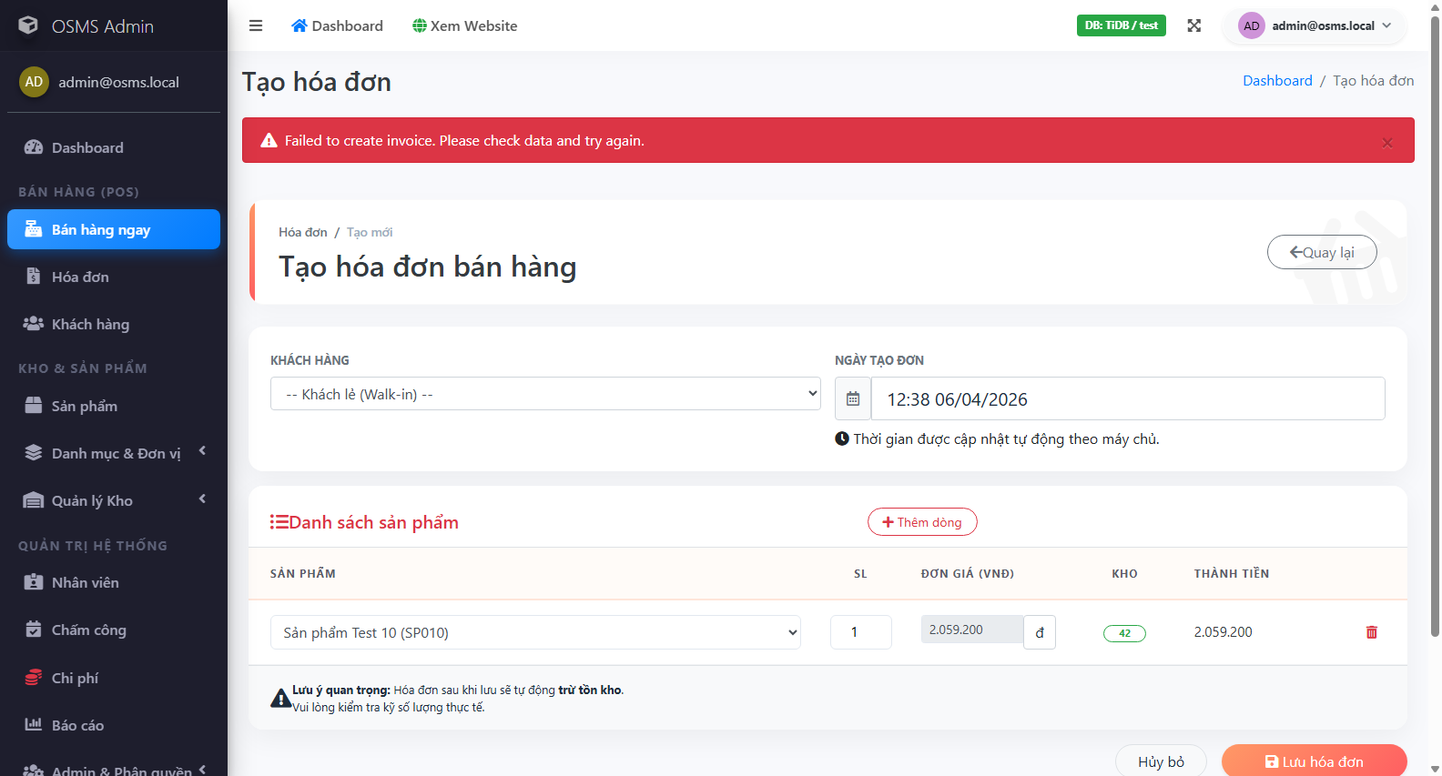
Figure ‎3.2-1: Defect-focused UI execution evidence for invoice creation failure.

API test cases
The API workbook contains 19 API test cases derived from 6 high-level API scenarios. The API cases use the same traceability principle as the UI cases, but add endpoint-specific fields such as method, authentication requirement, expected status code, and expected response body.
Table ‎3.2-3: Sample API test case specification
Field | Value
Test Case ID | TC-API-HLT-001
Scenario ID | SCN-API-001
Title | Health endpoint returns service availability metadata
Module | Health API
Endpoint | /api/v1/health
Method | GET
Auth Requirement | None
Test Data | Base URL=http://localhost:5068
Steps | 1 Ensure the application is running locally;  2 Send GET request to http://localhost:5068/api/v1/health using Postman or browser.
Expected Status Code | 200
Expected Body | JSON response contains non-empty fields for status, service, serverTimeUtc, and version; status value is ok.
Actual Result | Health endpoint returned 200 OK and all Newman assertions for status, service, serverTimeUtc, and version passed in the full collection rerun.
Status | Pass
Evidence / Note | Primary evidence: TestResults/Evidence/API/newman-full-run.txt ; Secondary artifact: TestResults/RunnerOutput/API/newman-results.xml

Test case allocation by member
Ownership allocation was used to satisfy the requirement that each member contributes at least ten non-overlapping test cases. UI cases were distributed by module cluster, while API cases were executed as a shared QA-team artifact due to their smaller surface and automation-centric nature.
Table ‎3.2-4: Test case allocation by member
Owner | Assigned UI cases | Allocation note
Hoang Van Thien | 17 | Authentication, permissions, admin, invoices, reports, and partial public-catalog coverage
Nguyen Thanh Dat | 13 | Customers, suppliers, purchases, and partial stock coverage
Le Quang Duy | 14 | Products, product import, public catalog, and partial stock coverage
QA Team | 19 | Shared ownership for API execution and automation evidence

This allocation keeps module ownership visible while preserving a shared quality baseline across the final package. It also supports defense readiness because each member can explain both the rationale and the execution evidence of the areas they owned.

Execution evidence summary
The final execution set is fully recorded in the final-results workbook and its linked evidence files. Every designed test case in the current report has a recorded execution outcome, and each failing case can be traced to supporting screenshots, runner outputs, and defect records. This makes the execution section easier to verify during review and presentation.
Table ‎3.2-5: Execution evidence summary
Metric | Value
Total executed test cases | 63
Pass | 56
Fail | 7
Admin UI cases | 41
Public UI cases | 3
API cases | 19
Execution completeness | 100% of the current baseline

Table ‎3.2-6: Execution evidence types
Evidence type | Purpose | Representative artifact
UI screenshots | Visual proof of page state and result outcome | Admin login, import preview, invoice failure screenshots
TRX runner output | Execution trace for focused UI automation reruns | UI rerun files under TestResults/RunnerOutput/UI
Newman TXT and XML | Exportable API automation proof | newman-full-run.txt and newman-results.xml
GitHub Issues | Professional bug-management evidence | Live issues for the four confirmed defects
Automation video | Presentation-ready execution walkthrough | OSMS-Automation-Demo.mp4

DEFECT REPORT & METRICS

Bug Management Tool and Workflow
This chapter explains how defects were controlled, documented, and summarized during the testing process. Because the course requires a real bug-management tool, the project used GitHub Issues as the official issue-tracking platform for confirmed defects. Defect records were synchronized between the issue tracker, the defect register, the final results workbook, and the supporting screenshots and runner outputs.

Selected tool
GitHub Issues was selected as the official bug-management tool for this submission. The tool is appropriate for the project because it supports issue IDs, labels, screenshots, comments, status tracking, and direct linking from the final result package. It also satisfies the course requirement to use a real issue-management platform rather than a manually typed bug list only.
The selected tool was used for the four confirmed defects that remained reproducible in the current execution baseline.
Table ‎4.1-1: Bug-management tool selection
Item | Value
Selected tool | GitHub Issues
Repository | Alucard30Dec/Online-Sales-Management-System
Used for | Confirmed product defects with reproducible evidence
Linked artifacts | Defect register, final results, screenshots, TRX/TXT/XML evidence
Reason selected | Real issue IDs, practical traceability, and direct repository integration

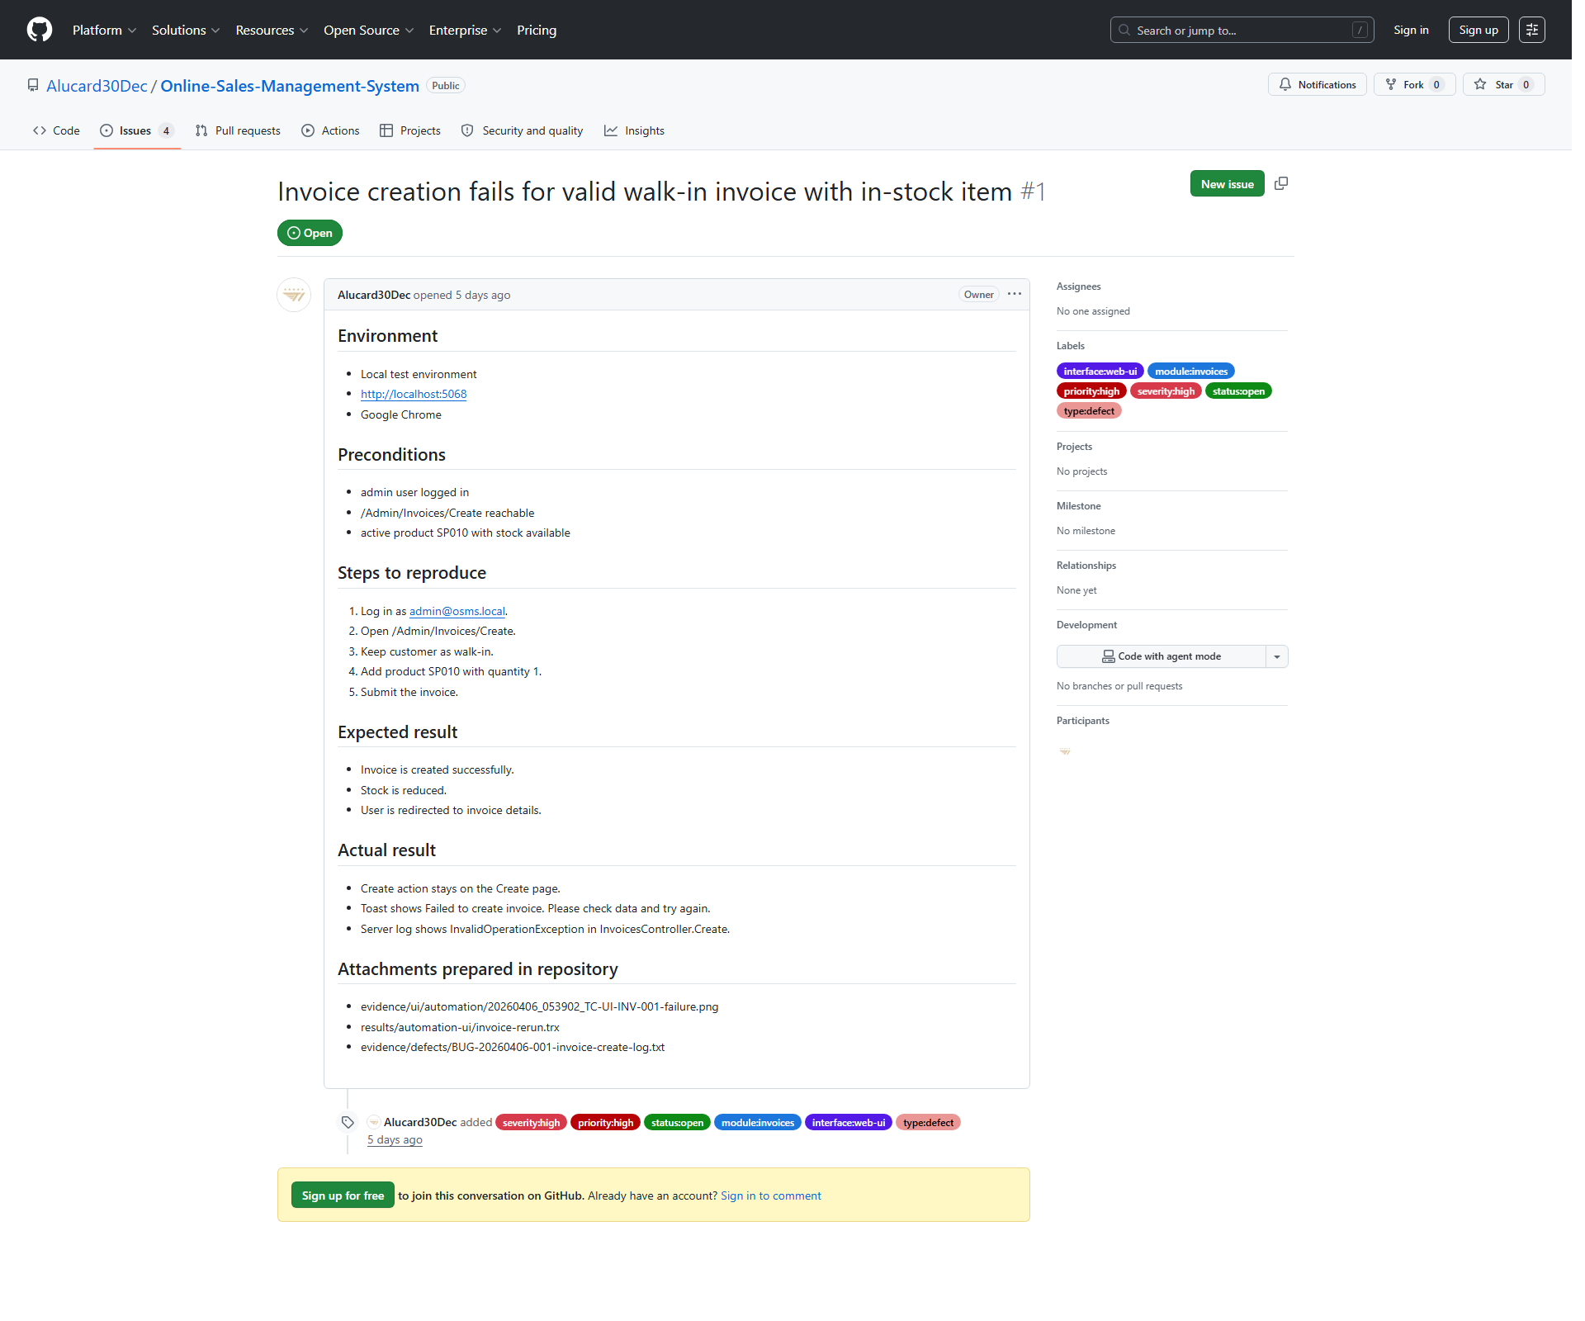
Figure ‎4.1-1: GitHub Issue example used as the official bug-management record for a confirmed defect.

Issue workflow
The issue workflow used in this submission was designed to keep defect reporting disciplined and evidence-based. An issue was created only after the mismatch was reproducible and supported by execution artifacts.
- Execute or rerun the related test case
- Compare actual behavior against the expected result
- Collect screenshots and runner outputs
- Classify the result as observation or confirmed defect
- Open a github issue for reproducible confirmed defects only
- Link the issue back to the defect register and final results workbook
- Keep the issue open until a real post-fix retest can verify closure
Table ‎4.1-2: Issue workflow
Step | Action | Expected output
1 | Execute or rerun the test case | Observable system result
2 | Collect screenshot and runner evidence | Supporting proof files
3 | Compare expected and actual behavior | Pass / Fail decision
4 | Classify as observation or confirmed defect | Defect triage decision
5 | Create GitHub Issue for confirmed defects | Live issue record with labels
6 | Sync register, results, and evidence mapping | Full traceability across artifacts
7 | Retest after fix when available | Potential closure or continued open status

Severity and priority rules
Severity and priority were assigned according to business impact, reproducibility, and operational risk. The project used simple but defensible rules so that each rating could be justified during presentation defense.
Table ‎4.1-3: Severity and priority rules
Rule area | How it was applied in this project
Severity: High | Used when the defect blocks a core business workflow such as invoice creation, invoice cancellation, or valid product import confirmation
Severity: Medium | Used when the system blocks invalid input correctly but still presents broken or unreadable validation feedback
Priority: High | Used when the defect affects transaction correctness, inventory, or core operational workflow
Priority: Medium | Used when the defect should be fixed but does not fully break the core transaction path
The actual issue labels used in GitHub include:
- Severity:high / severity:medium
- Priority:high / priority:medium
- Status:open
- Module:invoices / module:purchases / module:product-import
- Interface:web-ui
- Type:defect

Defect Log
At the final reporting point, the defect register contains 4 confirmed defects and 2 closed observations. The observations are retained for historical traceability, but only the confirmed defects are counted as active product defects in the summary metrics.

Critical and high severity defects
No active critical-severity defect exists in the current result set. However, three high-severity defects remain open and affect core business workflows. These findings are the most important defects in the report because they affect invoice processing, valid import completion, or other stock-sensitive behavior that directly influences business correctness.
Table ‎4.2-1: High-severity confirmed defects
Defect ID | Related test case(s) | Module | Severity | Priority | Current status | GitHub Issue
BUG-20260406-001 | TC-UI-INV-001; TC-UI-INV-003; TC-UI-INV-006 | Invoices | High | High | Open - Confirmed | https://github.com/Alucard30Dec/Online-Sales-Management-System/issues/1
BUG-20260411-003 | TC-UI-IMP-003 | Product Import | High | High | Open - Confirmed | https://github.com/Alucard30Dec/Online-Sales-Management-System/issues/3
BUG-20260411-004 | TC-UI-INV-005 | Invoices | High | High | Open - Confirmed | https://github.com/Alucard30Dec/Online-Sales-Management-System/issues/4


Figure ‎4.2-1: Reproduction evidence for the high-severity invoice creation defect.
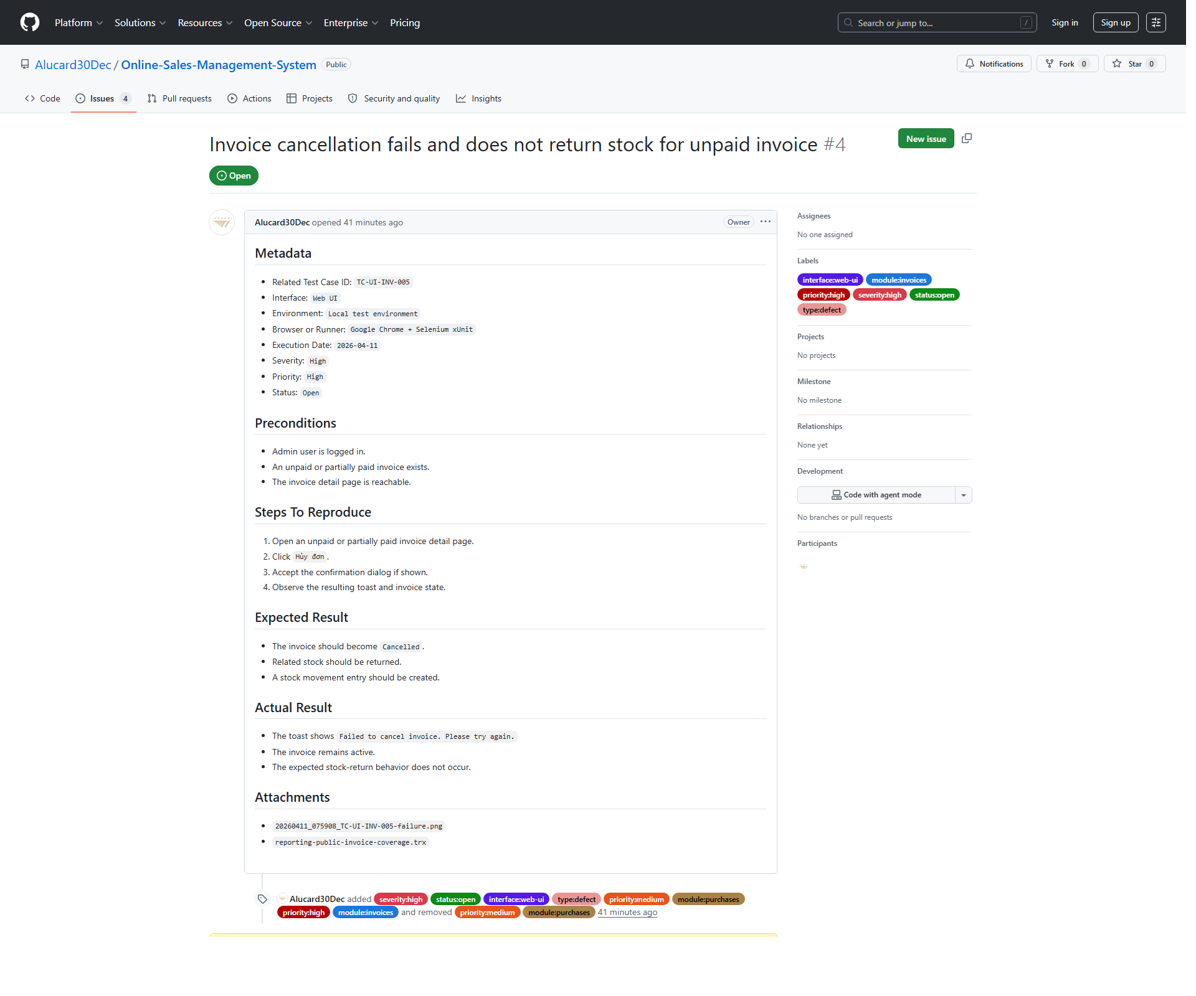
Figure ‎4.2-2: GitHub Issue evidence for a high-severity invoice cancellation defect.

Medium and low severity defects
The current result set contains one medium-severity confirmed defect and no low-severity confirmed defect. Although this defect does not break the blocking logic of the purchase-create flow, it still reduces usability by showing an unreadable validation banner instead of clear feedback to the user.
Table ‎4.2-2: Medium and low severity confirmed defects
Defect ID | Related test case(s) | Module | Severity | Priority | Current status | GitHub Issue
BUG-20260411-002 | TC-UI-PUR-002; TC-UI-PUR-003 | Purchases | Medium | Medium | Open - Confirmed | https://github.com/Alucard30Dec/Online-Sales-Management-System/issues/2
Low severity defects | None | - | Low | - | - | -

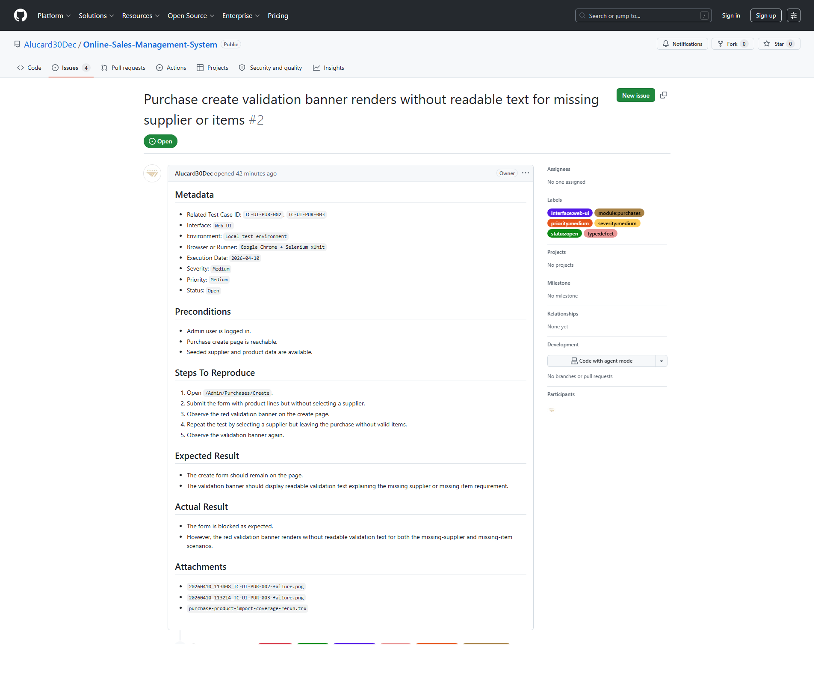
Figure ‎4.2-3: GitHub Issue evidence for the medium-severity purchase validation defect.

Screenshots and reproduction evidence
Each confirmed defect in the current report is supported by reproducible steps and at least one screenshot or runner artifact. The stronger defect packages also include focused rerun evidence and direct GitHub Issue screenshots. This makes the defect records easier to review and helps distinguish real product defects from temporary automation or expectation problems.
Table ‎4.2-3: Defect evidence mapping summary
Defect ID | Evidence types used | Purpose
BUG-20260406-001 | UI screenshots, TRX, server log excerpt, GitHub Issue screenshot | Proves invoice-create failure is reproducible and not limited to one scenario
BUG-20260411-002 | UI screenshots, focused rerun TRX, GitHub Issue screenshot | Proves purchase validation banner defect is reproducible
BUG-20260411-003 | UI screenshots, focused rerun TRX, GitHub Issue screenshot | Proves import confirmation still fails after valid preview
BUG-20260411-004 | UI screenshots, focused rerun TRX, GitHub Issue screenshot | Proves invoice cancellation still fails and stock return does not occur

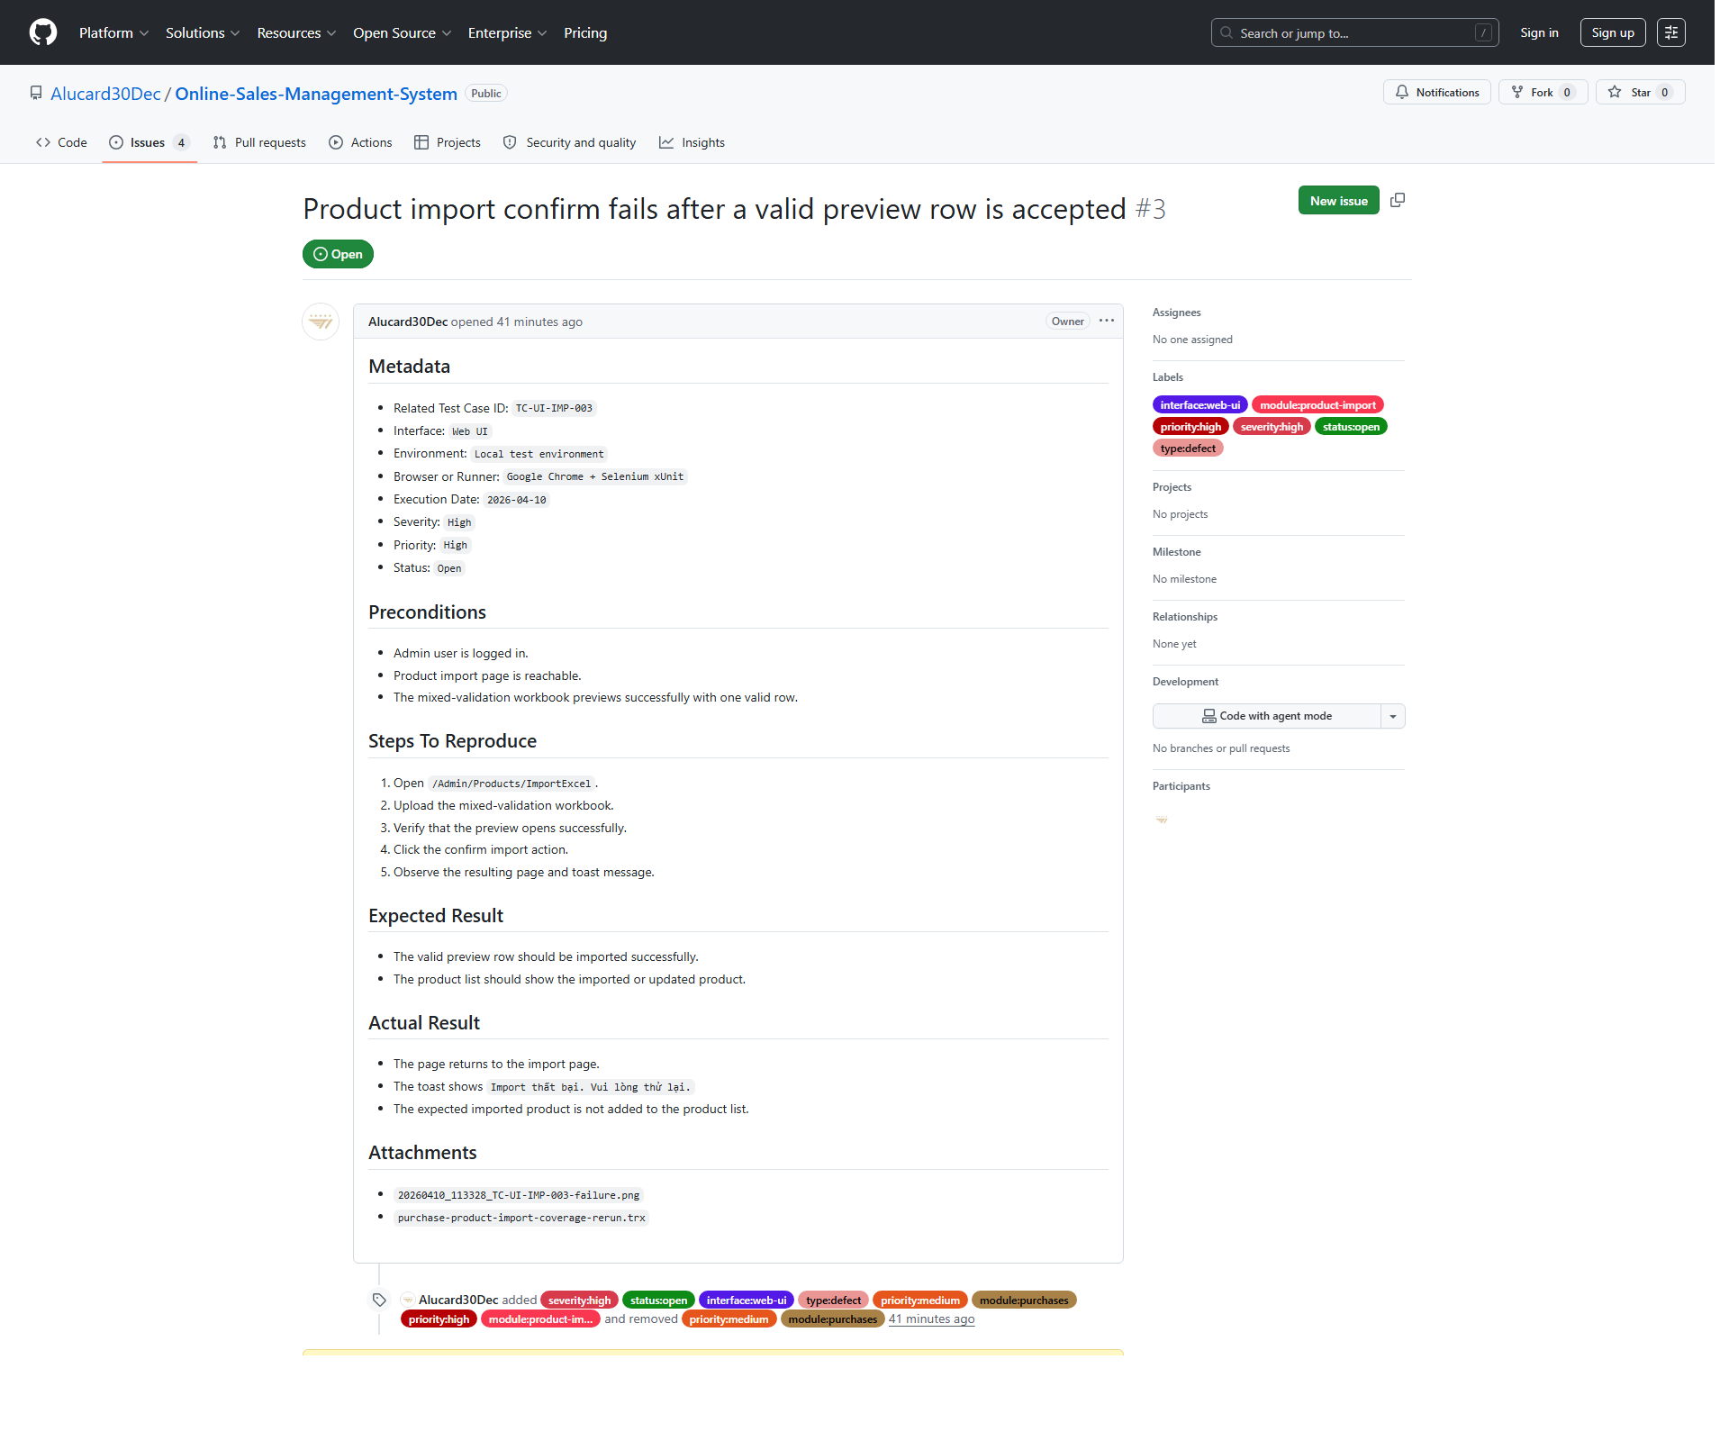
Figure ‎4.2-4: GitHub Issue evidence for the product-import confirmed defect.

Test Summary Metrics
The test summary metrics describe the final execution state of the project. It is important to distinguish between failing test cases and unique confirmed defects. In this report, 7 test cases currently fail, but those failures map to 4 confirmed defects because several failing cases are caused by the same underlying issue.

Total test cases executed
The current report contains 63 executed test cases. According to the synchronized final-results workbook, all designed UI and API cases in scope now have recorded execution outcomes, which means execution completeness reached 100% for the documented baseline.
Table ‎4.3-1: Execution totals
Metric | Value
Total test cases | 63
Executed test cases | 63
Execution progress | 100%

Pass/Fail/Blocked statistics
The final execution results contain 56 passing test cases, 7 failing test cases, and 0 blocked test cases. This corresponds to a pass rate of 88.89% and a fail rate of 11.11%.
Table ‎4.3-2: Pass / Fail / Blocked statistics
Status | Count | Interpretation
Pass | 56 | Expected behavior matched real execution evidence
Fail | 7 | Observed behavior did not match the expected result
Blocked | 0 | No blocked cases remain in the current baseline

Defect count by severity
Severity distribution should be interpreted using confirmed defects only, not raw failing test cases. The current confirmed-defect profile shows concentration in high-severity business workflows, especially invoice and product-import related behavior.
Table ‎4.3-3: Confirmed defect count by severity
Severity | Confirmed defect count
Critical | 0
High | 3
Medium | 1
Low | 0

Defect ratio and observations
The confirmed-defect ratio in the current report is 6.35%, calculated as 4 confirmed defects out of 63 executed test cases. This is lower than the fail-case rate of 11.11% because several failing test cases point to the same underlying defect. This distinction is important for accurate reporting because fail counts and defect counts do not always represent the same level of product impact.
In addition to the confirmed defects, the defect register also records 2 observations that were closed after rerun analysis. These records remain useful because they show that the team did not automatically classify every unexpected behavior as a product defect. Instead, each mismatch was reviewed and reclassified based on reproducible evidence.
Table ‎4.3-4: Defect ratio and observations
Metric | Value | Note
Confirmed defects | 4 | Unique product defects currently open
Failing test cases | 7 | Some failures share the same root cause
Defect ratio | 6.35% | Confirmed defects / executed test cases
Fail-case rate | 11.11% | Failing cases / executed test cases
Closed observations | 2 | Historical mismatch records resolved by rerun analysis

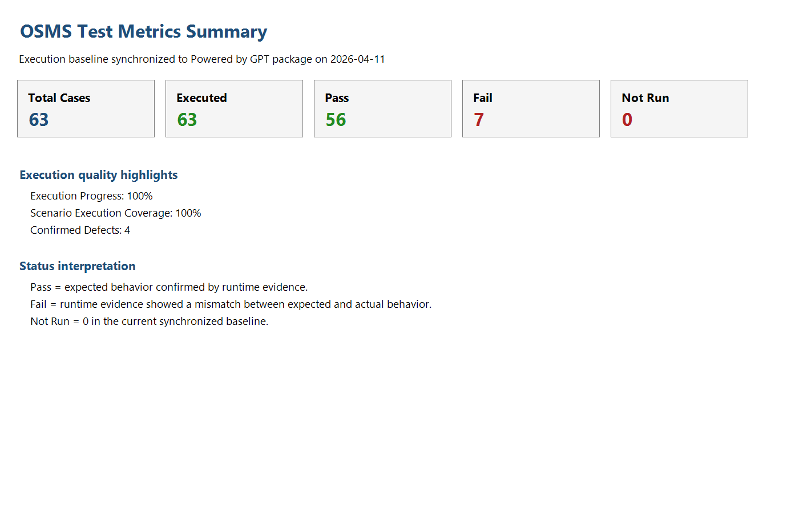
Figure ‎4.3-1: Metrics summary exported from the synchronized results workbook

CONCLUSION AND FUTURE WORK

Achievements and compliance with requirements
The final submission met the main academic and practical goals of the Software Testing project. The team produced a complete testing package that includes the report, presentation slides, scenario and test-case workbooks, final execution results, metrics, defect records, automation assets, supporting screenshots, runner outputs, and an automation demo video. These artifacts were synchronized so that the main claims in the report can be traced back to real execution outputs.
From an execution perspective, the project reached full recorded coverage with 63/63 executed test cases, 56 passing cases, 7 failing cases, 0 blocked cases, and no cases left as Not Run. Scenario coverage also reached 42/42, which means every documented scenario in scope was mapped and executed in the final evidence set.
The team also met the mandatory course requirements regarding individual contribution and defect handling. UI test-case ownership remained non-overlapping across members, each member contributed more than ten UI test cases, and confirmed defects were managed through a real GitHub Issues workflow with severity, priority, screenshots, and reproducible steps.
Table ‎5.1-1: Final requirement compliance summary
Requirement area | Current status | Supporting evidence
Group-based final testing project | Satisfied | Team allocation tables and shared submission package
At least 10 non-overlapping test cases per member | Satisfied | UI ownership counts: Hoang Van Thien=17, Nguyen Thanh Dat=13, Le Quang Duy=14
Industry-style test case fields | Satisfied | UI and API Excel/CSV test-case files
Execution evidence | Satisfied | Screenshots, TRX, TXT, XML, and final result workbook
Real bug-management tool | Satisfied | 4 live GitHub Issues linked from the defect register
Automation bonus support | Satisfied | Selenium UI runs, Newman outputs, and MP4 demo video
Submission packaging | Satisfied | MainReport, README.md, TestCases, TestResults, TestScript-Data, Videos
Table ‎5.1-2: Final delivery baseline
Measure | Value | Interpretation
Total test cases | 63 | Combined UI and API baseline
Executed test cases | 63 | Execution progress 100%
Pass / Fail / Blocked | 56 / 7 / 0 | Pass rate 88.89%, fail rate 11.11%
Scenario mapping | 42/42 | All documented scenarios mapped to test cases
Executed scenarios | 42/42 | Scenario execution coverage 100%
Confirmed defects | 4 | Backed by GitHub Issues and screenshots


Figure ‎5.1-1: Final execution and metrics summary used to support the conclusion of the testing project.

Challenges and limitations
Although the submission achieved full execution coverage for the documented test-case baseline, several limitations remain. These limitations do not invalidate the test results, but they explain why the current package should be described as a strong and evidence-backed submission rather than as proof that the product is defect-free.
- 4 confirmed defects remain open at the reporting point, including 3 high-severity defects and 1 medium-severity defect.
- The project captured defect discovery and live issue tracking, but post-fix retest evidence is still unavailable because the underlying product defects were not fixed within the current cycle.
- Cross-browser evidence exists only at a basic smoke level on Microsoft Edge; it is not a full compatibility certification matrix.
- The system was tested in a controlled local environment rather than a production-like staging environment.
- Non-functional areas such as load, penetration, accessibility, and recovery testing were intentionally excluded from scope.
The most important practical limitation is that the defect lifecycle is not fully closed. The team successfully identified, documented, and classified defects, but closure-level verification still depends on future product fixes followed by a controlled retest cycle.
Table ‎5.2-1: Current limitations and impact
Limitation | Current impact | Reason it remains open
Open confirmed defects | Product cannot be claimed defect-free | Fixes were not completed before the final reporting point
No post-fix pass retest | Defect lifecycle is not fully closed | No new build with verified fixes was available
Limited browser matrix | Compatibility claims must remain conservative | Only Chrome baseline plus Edge smoke were executed
Local environment only | Deployment-specific behavior was not certified | The course project was executed in a local environment
Out-of-scope non-functional testing | Performance and security conclusions are limited | These areas were outside the official functional scope


Figure ‎5.2-1: Example of a confirmed open defect that remains unresolved at the final reporting point.

Suggestions for future enhancements
Future work should focus first on product risk reduction and then on process maturity. The next cycle should prioritize defect fixing and closure, because this is the shortest path to improving actual software quality rather than only improving documentation quality.
- Fix the four confirmed open defects and perform controlled post-fix retests with updated evidence.
- Expand browser coverage beyond Chrome and the current Edge smoke run to build a stronger compatibility baseline.
- Add more negative and resilience-oriented API tests, especially for invalid filters, unsupported values, and boundary conditions.
- Broaden automation coverage for high-value regression flows while keeping outputs mapped to the official test-case IDs.
- Introduce CI-based automation execution so that UI and API smoke runs can be reproduced more consistently after future changes.
From an academic point of view, the submission already demonstrates structured planning, evidence-based execution, real defect management, and practical automation support. From an engineering point of view, the next cycle should focus on closing the defect lifecycle by fixing the open defects and validating the fixes through controlled retests.
Table ‎5.3-1: Recommended future enhancement roadmap
Priority | Enhancement | Expected benefit
1 | Fix open confirmed defects and rerun retests | Closes the defect lifecycle and improves product stability
2 | Extend browser compatibility verification | Improves confidence in UI consistency across browsers
3 | Increase API negative-path automation | Strengthens backend validation coverage
4 | Expand UI regression automation | Improves repeatability for critical business flows
5 | Move automation to CI or scheduled reruns | Improves repeatable verification after changes

Figure ‎5.3-1: Existing automation evidence that can be expanded in future iterations to increase regression strength.
Overall, the final submission meets the required deliverables and reflects a credible software-testing process supported by real execution outputs, defect records, metrics, and GitHub-based issue tracking. The package is ready for submission, and the team can explain the reported results clearly during the presentation. The remaining work is mainly product-side: fixing the confirmed defects and rerunning focused regression checks after those fixes are available.

APPENDIX
- GitHub
The final submission package is stored in the project repository under the clean submission folder so that the examiner can access the report, test cases, results, automation assets, and video from one consistent location.
Table A.1: GitHub submission links
Item | Link / location
GitHub Repository | https://github.com/Alucard30Dec/Online-Sales-Management-System
Clean submission package | https://github.com/Alucard30Dec/Online-Sales-Management-System/tree/main/Report%20Test%20subject/Powered%20by%20GPT
Top-level folders in clean package | MainReport, README.md, TestCases, TestResults, TestScript-Data, Videos

- Excel test cases
The official test-case artifacts are maintained in Excel-compatible workbook and CSV form. These files are used as the main reference for scenario mapping, ownership, execution details, and cross-checking with the final result package.
Table A.2: Excel and scenario artifacts
Artifact | Package-relative path | Purpose
UI test cases workbook | TestCases/UI/OSMS-UI-Test-Cases.xlsx | 44 UI test cases with ownership, expected and actual results, and status
API test cases workbook | TestCases/API/OSMS-API-Test-Cases.xlsx | 19 API test cases with request and result coverage
UI test cases CSV | TestCases/UI/OSMS-UI-Test-Cases.csv | CSV export for traceability and automation-friendly review
API test cases CSV | TestCases/API/OSMS-API-Test-Cases.csv | CSV export for API case review
Scenario list | TestCases/Scenarios/test-scenarios.md | Documented UI and API scenario set used to derive the test cases

- Test script and test data
The automation scripts and prepared test data used in the final submission are stored in the TestScript-Data folder. These artifacts support manual reruns, UI automation, API automation, and data-driven validation scenarios such as product import.
Table A.3: Test scripts and test data
Artifact group | Package-relative path | Notes
Automation root | TestScript-Data/Automation/ | Contains UI and API automation assets
UI automation | TestScript-Data/Automation/ui/ | Selenium WebDriver + .NET 8 + xUnit test project
API automation | TestScript-Data/Automation/api/ | Postman collection, environment, and Newman run script
Test data root | TestScript-Data/TestData/ | Prepared seeded data and import files
Account data | TestScript-Data/TestData/accounts/OSMS-Test-Accounts.md | Seeded accounts used for role-based verification
Import data | TestScript-Data/TestData/ui/ | Mixed-validation and negative import files
API data | TestScript-Data/TestData/api/OSMS-API-Test-Data.json | Reference values for API execution

Verified tools used in the submission package:
- Visual Studio / .NET 8 tooling for application build and UI automation execution
- Google Chrome and Microsoft Edge for browser-based execution
- Postman and Newman for API execution
- GitHub Issues for defect management
- Excel-compatible workbooks and CSV files for test cases, final results, and metrics
- Microsoft Word and PowerPoint for the final report and presentation deliverables
Generative AI was used only in a limited supporting role for requirement summarization, naming suggestions, grammar review, and coding guidance. It was not used to fabricate execution evidence, defects, or final results. All submission-facing content was reviewed manually by the team and aligned with real execution artifacts before inclusion in the report.
- Final results workbook and images
The final execution results are documented in the result workbook and the supporting evidence folders. These files are used to support the pass, fail, and defect claims presented in the report.
Table A.4: Final results and evidence package
Artifact | Package-relative path | Purpose
Final results workbook | TestResults/FinalResults/OSMS-Final-Test-Results.xlsx | Records 63 executed cases with final status
Final results CSV | TestResults/FinalResults/OSMS-Final-Results.csv | Summary baseline: 56 Pass / 7 Fail
Execution-evidence mapping | TestResults/FinalResults/execution-evidence-mapping.csv | Links test cases to screenshots, runner outputs, and issues
Metrics workbook | TestResults/Metrics/OSMS-Test-Metrics.xlsx | Aggregated metrics and summary views
UI evidence | TestResults/Evidence/UI/automation/ | Screenshots proving UI execution outcomes
API evidence | TestResults/Evidence/API/newman-full-run.txt | Text summary of Newman API execution
Report evidence | TestResults/Evidence/Report/ | Screenshots of metrics and report-support visuals

- Automation video
The submission includes a recorded automation video used to demonstrate UI and API execution evidence in a concise presentation-friendly format.
Table A.5: Automation video artifacts
Artifact | Package-relative path | Purpose
Automation demo video | Videos/OSMS-Automation-Demo.mp4 | Primary automation demonstration artifact
Video description | Videos/Automation-Video-Description.md | Explains covered flows and evidence mapping
Recording script | Videos/record-automation-demo.ps1 | Repeatable capture workflow for the demo package

- Bug tracker screenshots
Bug-management evidence is stored in both workbook and screenshot form. The defect package combines the defect register, the workbook log, and four live GitHub Issues for the confirmed defects included in the final report.
Table A.6: Bug tracker and defect artifacts
Artifact | Package-relative path | Notes
Defect register CSV | TestResults/Defects/OSMS-Defect-Register.csv | 4 confirmed defects plus closed observations
Defect log workbook | TestResults/Defects/OSMS-Defect-Log.xlsx | Submission-facing defect tracking workbook
GitHub issue screenshots | TestResults/Evidence/Defects/ | Screenshots for issues #1, #2, #3, and #4
GitHub issue checklist files | TestResults/Defects/GitHubIssues/ | Structured issue drafts and evidence notes

REFERENCES
Bootstrap. (n.d.). Get started with Bootstrap. Bootstrap v5.3. Retrieved April 12, 2026, from https://getbootstrap.com/docs/5.3/getting-started/introduction/

GitHub. (n.d.). About Git. GitHub Docs. Retrieved April 12, 2026, from https://docs.github.com/en/get-started/using-git/about-git

Microsoft. (2023, January 12). Migrations overview. Microsoft Learn. https://learn.microsoft.com/en-us/ef/core/managing-schemas/migrations/

Microsoft. (2024, June 17). Overview of ASP.NET Core MVC. Microsoft Learn. https://learn.microsoft.com/en-us/aspnet/core/mvc/overview

Microsoft. (2024, November 12). Overview of Entity Framework Core. Microsoft Learn. https://learn.microsoft.com/en-us/ef/core/

Microsoft. (2025, July 30). Overview of ASP.NET Core. Microsoft Learn. https://learn.microsoft.com/en-us/aspnet/core/overview

Microsoft. (2025, November 12). Introduction to Identity on ASP.NET Core. Microsoft Learn. https://learn.microsoft.com/en-us/aspnet/core/security/authentication/identity

TASK DIVISION AND CONTRIBUTION SUMMARY
The following summary reflects the primary UI test-case ownership used in the final report, together with the main integration responsibilities visible in the submission package. The workload percentage is based on non-overlapping UI ownership because that is the clearest and most verifiable individual contribution in the current artifacts.
Table T.1: Task division and contribution summary
Member name | Assigned tasks | Workload contribution (%) | Completion status (%)
Hoàng Văn Thiên | Project audit, traceability alignment, final integration, authentication, permissions, admin management, invoices, reports, partial public catalog | 33.33% | 100%
Nguyễn Thành Đạt | Customers, suppliers, purchases, partial stock workflows | 33.33% | 100%
Lê Quang Duy | Products, product import, partial stock, public catalog workflows | 33.33% | 100%
Note: the workload contribution percentage above is calculated from primary UI ownership only. Shared API execution, report consolidation, and package synchronization were completed collaboratively and are therefore described in the assigned-task column instead of being redistributed numerically.

